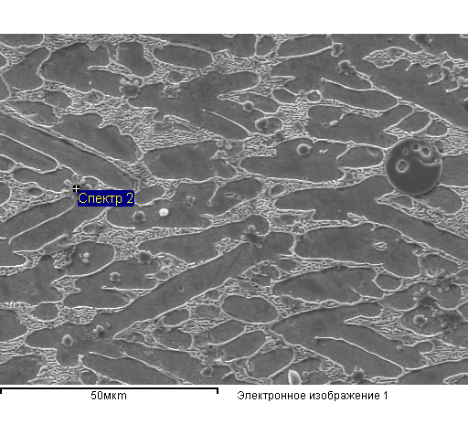

Structure element 1 Structure element 2

|  |  |  |  |  |  |  |
| --- | --- | --- | --- | --- | --- | --- |
| Element | Mass. % | Atomic% |  | Element | Mass. % | Atomic% |
| N K | 12.22 | 27.59 |  | O K | 33.67 | 60.36 |
| O K | 12.19 | 24.09 |  | Ti K | 65.39 | 39.15 |
| Ti K | 58.45 | 38.60 |  | Fe K | 0.94 | 0.48 |
| Fe K | 17.15 | 9.71 |  | Total | 100.00 |  |
| Total | 100.00 |  |  |  |  |  |

Structure element 3 Structure element 4

|  |  |  |  |  |  |  |
| --- | --- | --- | --- | --- | --- | --- |
| Element | Mass. % | Atomic% |  | Element | Mass. % | Atomic% |
| N K | 6.00 | 13.09 |  |  |  |  |
| O K | 21.58 | 41.22 |  | Ti K | 26.64 | 29.75 |
| Ti K | 67.00 | 42.73 |  | Fe K | 73.36 | 70.25 |
| Fe K | 5.42 | 2.96 |  |  |  |  |
| Total | 100.00 |  |  | Total | 100.00 |  |

Structure element 5 Structure element 6

|  |  |  |  |  |  |  |
| --- | --- | --- | --- | --- | --- | --- |
| Element | Mass. % | Atomic% |  | Element | Mass. % | Atomic% |
| C K | 2.82 | 11.70 |  | Ti K | 4.59 | 5.31 |
| Ti K | 10.30 | 10.72 |  | Fe K | 95.41 | 94.69 |
| Fe K | 86.88 | 77.58 |  | Total | 100.00 |  |
| Total | 100.00 |  |  |  |  |  |

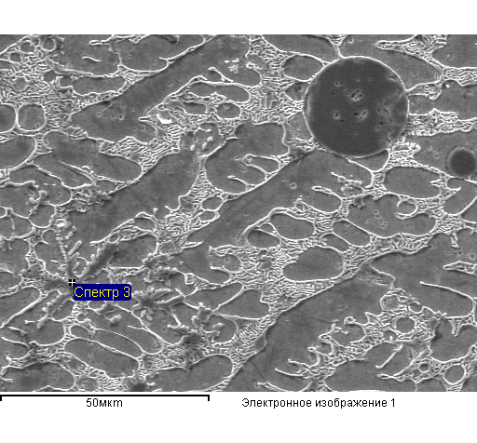

Structure element 7

|  |  |  |
| --- | --- | --- |
| Element | Mass. % | Atomic% |
| N K | 10.28 | 23.62 |
| O K | 13.93 | 28.03 |
| Ti K | 48.85 | 32.83 |
| Fe K | 26.94 | 15.53 |
| Total | 100.00 |  |

Structure element 8 Structure element 9

|  |  |  |  |  |  |  |
| --- | --- | --- | --- | --- | --- | --- |
| Element | Mass. % | Atomic% |  | Element | Mass. % | Atomic% |
| N K | 0.45 | 1.69 |  | O K | 32.68 | 59.28 |
| Ti K | 26.71 | 29.44 |  | Ti K | 66.57 | 40.33 |
| Fe K | 72.84 | 68.87 |  | Fe K | 0.75 | 0.39 |
| Total | 100.00 |  |  | Total | 100.00 |  |

Structure element 10

|  |  |  |
| --- | --- | --- |
| Element | Mass. % | Atomic% |
| C K | 3.19 | 13.07 |
| Ti K | 11.25 | 11.56 |
| Fe K | 85.56 | 75.38 |
| Total | 100.00 |  |

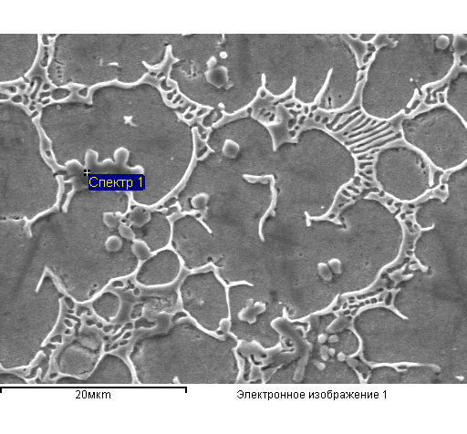

Structure element 11 Structure element 12

|  |  |  |  |  |  |  |
| --- | --- | --- | --- | --- | --- | --- |
| Element | Mass. % | Atomic% |  | Element | Mass. % | Atomic% |
| N K | 6.74 | 14.47 |  | N K | 1.76 | 3.68 |
| O K | 22.03 | 41.39 |  | O K | 30.01 | 54.95 |
| Ti K | 64.94 | 40.76 |  | Ti K | 64.18 | 39.24 |
| Fe K | 6.29 | 3.38 |  | Fe K | 4.05 | 2.12 |
| Total | 100.00 |  |  | Total | 100.00 |  |

Structure element 13 Structure element 14

|  |  |  |  |  |  |  |
| --- | --- | --- | --- | --- | --- | --- |
| Element | Mass. % | Atomic% |  | Element | Mass. % | Atomic% |
| C K | 4.12 | 16.52 |  | C K | 3.87 | 15.58 |
| Ti K | 5.43 | 5.46 |  | Ti K | 8.69 | 8.77 |
| Fe K | 90.45 | 78.01 |  | Fe K | 87.43 | 75.65 |
| Total | 100.00 |  |  | Total | 100.00 |  |

Structure element 15

|  |  |  |  |  |  |  |
| --- | --- | --- | --- | --- | --- | --- |
| Element | Mass. % | Atomic% |  | Element | Mass. % | Atomic% |
| Ti K | 27.06 | 30.19 |  | Ti K | 26.72 | 29.83 |
| Fe K | 72.94 | 69.81 |  | Fe K | 73.28 | 70.17 |
| Total | 100.00 |  |  | Total | 100.00 |  |

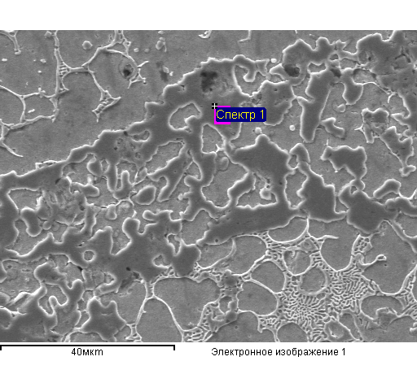

Structure element 16

|  |  |  |
| --- | --- | --- |
| Element | Mass. % | Atomic% |
| N K | 5.06 | 10.60 |
| O K | 25.62 | 46.99 |
| Ti K | 68.57 | 42.02 |
| Fe K | 0.76 | 0.40 |
| Total | 100.00 |  |

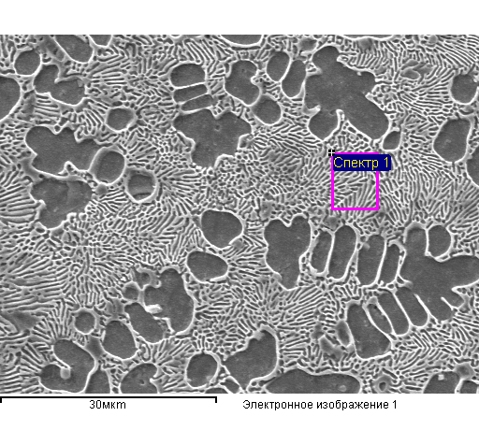

Structure element 17 Structure element 18

|  |  |  |  |  |  |  |
| --- | --- | --- | --- | --- | --- | --- |
| Element | Mass. % | Atomic% |  | Element | Mass. % | Atomic% |
| C K | 2.21 | 9.32 |  | C K | 1.92 | 8.19 |
| Ti K | 12.19 | 12.91 |  | Ti K | 13.25 | 14.14 |
| Fe K | 85.61 | 77.77 |  | Fe K | 84.83 | 77.67 |
| Total | 100.00 |  |  | Total | 100.00 |  |

Structure element 19

|  |  |  |
| --- | --- | --- |
| Element | Mass. % | Atomic% |
| Ti K | 24.79 | 27.76 |
| Fe K | 75.21 | 72.24 |
| Total | 100.00 |  |

Structure element 20

|  |  |  |
| --- | --- | --- |
| Element | Mass. % | Atomic% |
| C K | 4.12 | 16.53 |
| Ti K | 5.67 | 5.70 |
| Fe K | 90.20 | 77.77 |
| Total | 100.00 |  |

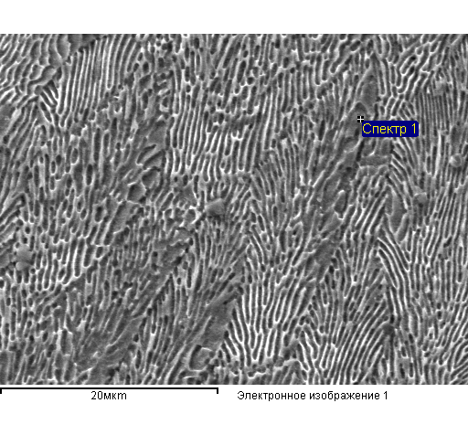

Дендрит эвтектики Общий спектр

|  |  |  |  |  |  |  |
| --- | --- | --- | --- | --- | --- | --- |
| Element | Mass. % | Atomic% |  | Element | Mass. % | Atomic% |
| C K | 2.35 | 9.14 |  | Ti K | 13.02 | 14.86 |
| O K | 3.26 | 9.54 |  | Fe K | 86.98 | 85.14 |
| Ti K | 15.97 | 15.60 |  | Total | 100.00 |  |
| Fe K | 78.43 | 65.73 |  |  |  |  |
| Total | 100.00 |  |  |  |  |  |

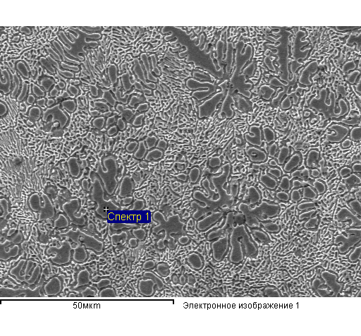

Дендриты

|  |  |  |
| --- | --- | --- |
| Element | Mass. % | Atomic% |
| Ti K | 4.53 | 5.24 |
| Fe K | 95.47 | 94.76 |
| Total | 100.00 |  |

Эвтектика

|  |  |  |
| --- | --- | --- |
| Element | Mass. % | Atomic% |
| Ti K | 12.97 | 14.80 |
| Fe K | 87.03 | 85.20 |

Общий спектр

|  |  |  |
| --- | --- | --- |
| Element | Mass. % | Atomic% |
| Ti K | 12.18 | 13.92 |
| Fe K | 87.82 | 86.08 |
| Total | 100.00 |  |

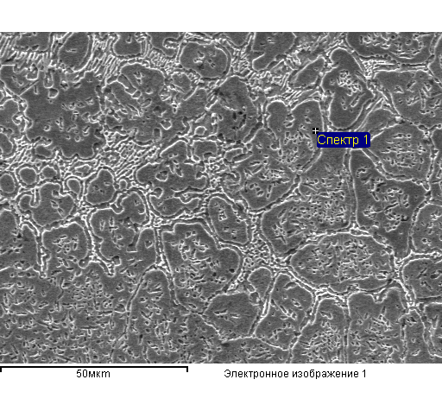

Зерна

|  |  |  |
| --- | --- | --- |
| Element | Mass. % | Atomic% |
| Ti K | 4.75 | 5.50 |
| Fe K | 95.25 | 94.50 |
| Total | 100.00 |  |

Границы

|  |  |  |
| --- | --- | --- |
| Element | Mass. % | Atomic% |
| C K | 2.95 | 12.22 |
| Ti K | 9.23 | 9.58 |
| Fe K | 87.82 | 78.20 |
| Total | 100.00 |  |